SSCGA Herding Day 2027
Sunday, March 13, 2027
At
Wood’s End Farm
2225 Salem Road,
Watkinsville, GA 30677

Limited to first 25 dogs to sign up.
Sheltie Club members get first preference,
Then Non Member Shelties, then other breeds.

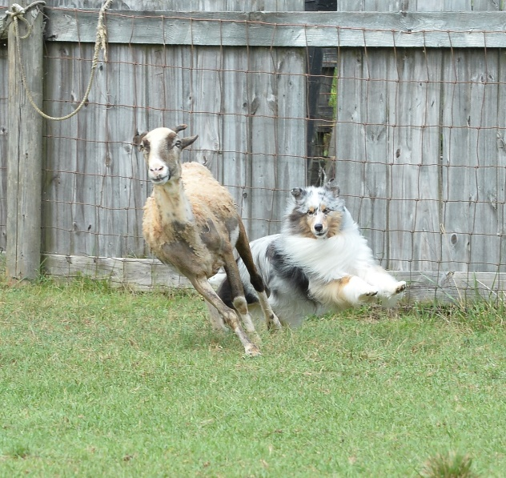

Club Members: $25 per dog
Non Club Members: $30 per dog

- First round starts at 10:00 am
  - Plan to arrive 15-30 minutes early to check in and set up.
- Club meeting and potluck picnic lunch at Doyle’s Party house
  - Fried Chicken and Water provided by club
  - Contact Janet at jpcalpin@gmail.com for items to bring for the picnic and RSVP
- Second round if time allows
Bring your drinks, chair, crate/exPen, water and shade for your dog, etc.

Use Form at the following link below to sign up online:
https://forms.gle/VZbJvBEMDNoNUYYXA
or Email gfbonner@gmail.com to sign up

